15.44: a) (i)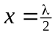 is a node, and there is no motion. (ii) 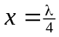 is an antinode, and and this factor multiplies the results of (ii), so 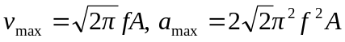. b) The amplitude is 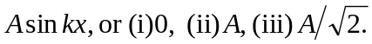 c) The time between the extremes of the motion is the same for any point on the string (although the period of the zero motion at a node might be considered indeterminate) and is 